One of the most important lessons to learn on this course is that a creative solution must be directed through a design process. Design is the process of turning a brief and all its requirements, into a finished product or design solution.

There are many areas of a design process including:

* following a series of steps to help you stick to a deadline,
* ensuring you conduct the necessary research to inform your designs,
* providing opportunities to make checks to ensure creative concepts meet the aims of the brief,

…and much more.

But the design process is only a guideline.

Every designer’s creative process is different and approaches can vary. Whatever the approach, adhering to steps in a design process will provide guidelines, tools and techniques that will help make a project run smoothly. As each project is unique, it is ultimately up to the individual to carve out their own approach and establish what works best for them. There is no one right answer so you will each develop your own solution to the brief.

The important thing is to try to challenge yourself and to experiment and take risks. Be sure to question assumptions and see if you can discover some new skills. And don’t be afraid to get it ‘wrong’. Fail fast and learn from your mistakes. This is where lessons are learned and in order to make progress, exploration towards good ideas will have to contain some of the more obvious or random ideas as well.

## The 10-Step Design Process

Ideally, the design process follows a flow that can be represented as a cycle, but it can also be a linear process with interjection points. The process is adaptable and will respond well to revisions and amendments.

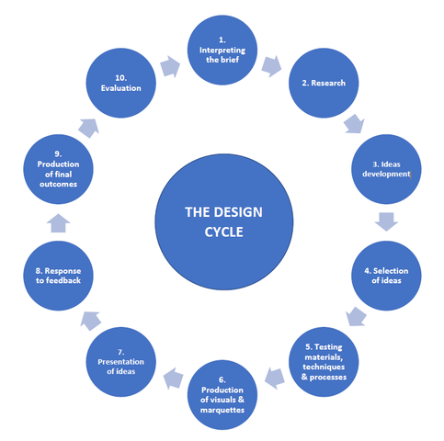

Fig. 1. The Design Cycle

The design cycle (see fig. 1) is a methodology used to develop creative work from ideas generation to finished product. Designers can adapt the cycle to suit their own practice. Depending on the size or complexity of a project, the process can be broken into a smaller or larger number of stages. All elements of the cycle will be included regardless of the number of stages that are chosen. For example, some projects might need more research than others so this stage might be broken up into a number of smaller, more manageable steps. Some projects might have a six-stage process while more complicated projects could have 10.

Following the design cycle ofa process ensures the designer takes a step-by-step approach to completing any project. The design cycle promotes awareness of the following activities which the designer will engage in, document and record for future reference:

* Gathering client and project information
* Finding inspiration
* Design development
* Project and materials research
* Selecting and testing materials
* Generating project visuals
* Presenting the project designs
* Obtaining client feedback
* Modifying the design with an alternative solution, if necessary
* Self-evaluation of works and methods

## Stage 1: Interpreting the brief

The first thing you need to do is ask yourself what it is you are being asked to do? This is normally outlined in a client brief. A client brief is formulated by a completed client questionnaire and a site survey. The questionnaire will either be completed by your client in their own time, or you will complete it with them, during your first consultation with them.

A site survey, which includes a dimensional survey and a photographic one, is carried out on site by you, and includes all the data you need on the space you will be working on (measurements, images, damages etc.). As the project progresses, you should constantly refer back to the brief to keep you on track.

The brief should determine a client wish list, but should also take other information into consideration so that the proposed design can be developed and produced. When compiling and working with a client brief, remember that it is important to record the following information:

* The location of the property - for example, will there be issues with access?
* The existing space in terms of finishes, fixed features, lighting and location of windows and doors as outlined in the site survey
* Room use - for example, who will be using the room? This will affect the choices you make in terms of colour, fabrics and furniture choices
* Client wish list - make a list of the items that the client has expressed they would like incorporated within the design (e.g. kitchen with island, living space with sofa bed)

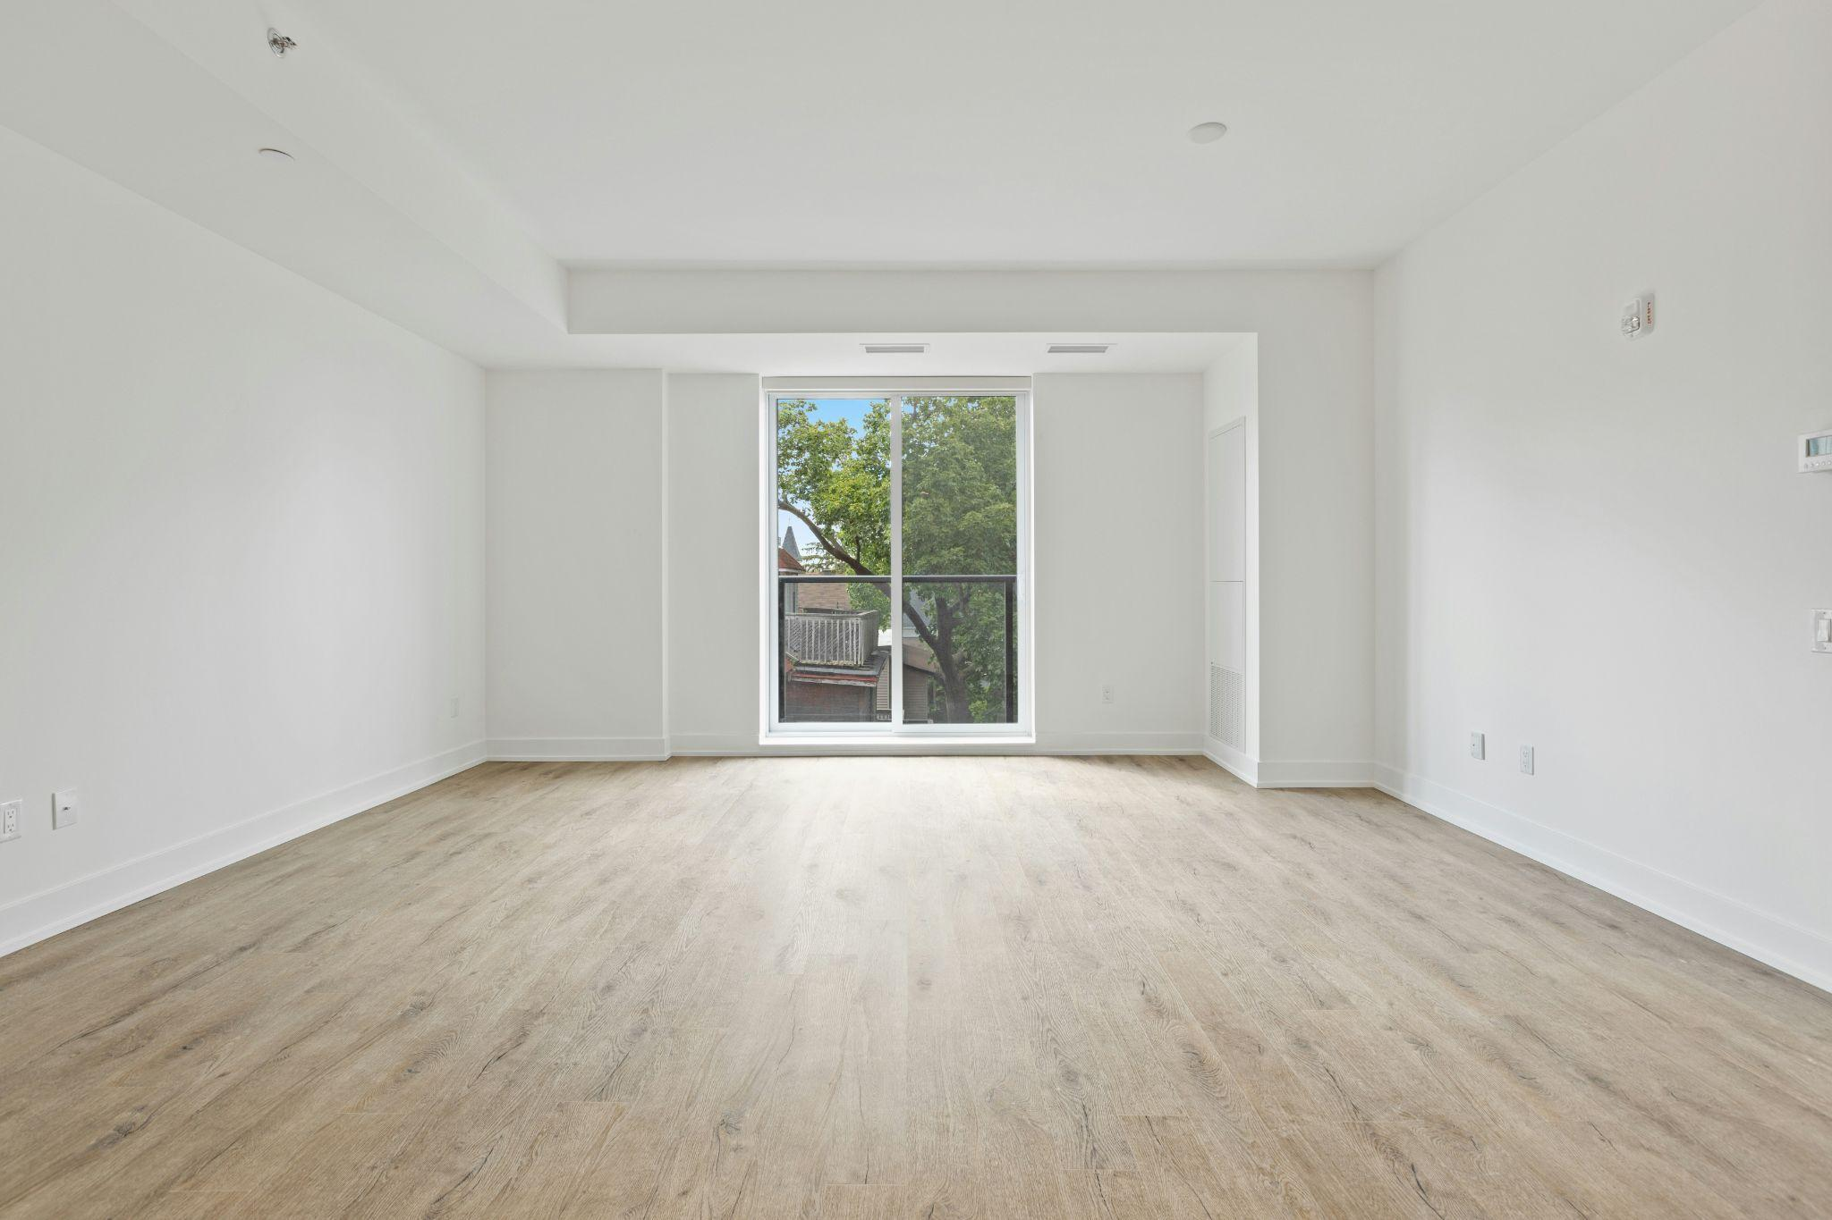

Fig. 2. Unsplash (n.d.), Part of interpreting a brief includes a site survey

## Stage 2: Research

The next phase is where you get to know the subject of the brief and gather all the facts. This also involves gathering visual research. In addition to visual research on your subject matter, you should see what you can learn from examples of other design solutions of a similar nature to your project.

Carrying out research relevant to the brief, will ensure that you explore comparable design solutions. You will investigate various sources of information relevant to your project brief.

Research methods include both primary and secondary research.

* Primary research is classified as research that is conducted by the interior designer themself (i.e. you). This is research that is carried out through a variety of methods in order to understand more about a particular topic, such as interviews, visits to designated places, etc.
* Secondary research relies on researching existing sources. Here, you are relying on another person’s content to inform your own understanding of a topic including reading articles, books, etc. .

## Stage 3: Ideas development

Idea generation refers to the process in which designers create or produce work in response to a problem, project, or task. While generating new ideas can be challenging, in order to maintain longevity in any creative field, it is a vital part of the creative design cycle and an important skill to practise and develop.

The ideation phase is where you get to play with the information you have gathered. Take what you have learned from your research stage and further explore this by developing ideas that might lead to solutions to the problem. In this stage, you are examining how different task areas will work in relation to each other within the given scope of the project.

By using your research from stage 1 and 2, you will take a copy of a floor plan and layout different zones for each task area that might be required for your project, in the form of a bubble diagram. For example, if you have decided you will need a kitchen zone, sleeping zone, eating zone etc., you will attribute each one of these in the form of a bubble within the given floorplan of the space. This method will allow you to generate and develop different zoning areas, while considering the requirements within each zone. At this point, it is important to explore as many solutions as possible, even if in theory they seem “wrong”. Putting your ideas on paper will help you to eliminate impractical solutions, but also identify the potential in ideas that might be “outside the box”.



Fig. 3. Pexels (n.d.), Using floor plans is useful when experimenting with spatial layouts

## Stage 4: Selection of ideas

Now that you have developed some key concepts, like your zoning areas (stage 3), you will select the most suitable option. Once you have done so, it is time to interpret each zone as a specific furniture layout. For each zone, think about the potential orientation of the furniture you need to incorporate but at this beginning stage, you are not yet committing to a particular furniture layout. For example, your kitchen area may have an island, or it may be an L shaped kitchen. Look at as many options as possible and test their effectiveness by implementing traffic flows into each one. Testing each option with the use of a traffic flow will ensure you have selected the most suitable furniture layout for each zone. A good traffic flow is a typical response to how the user will enter and move around the space, and is indicated with the use of directional arrows. The final selection of ideas can only be determined once the designer is confident that the space offers ease of movement for the end user. By the end of this stage, you should have a final furniture layout with a clear traffic flow.

## Stage 5: Testing materials, techniques and processes

This stage involves testing materials, techniques and processes to develop your final design solutions. This involves:

1. researching different **materials** for each element (i.e. flooring, wall covering, window treatments etc.)
2. looking at the **techniques** used to finish each one (e.g. sealed marble countertops in a kitchen, means that the material is water tight and fit for purpose)
3. Deciding on the **process** needed in order to apply each material (i.e. tiles need to be laid on flooring)

In order for you to fully test the materials, you will research at least two options for each design element, take a copy of the floor plan and further examine how appropriate your chosen materials are through visual representation, for example, with the use of rendering mediums. This stage might also include the sourcing of material samples.

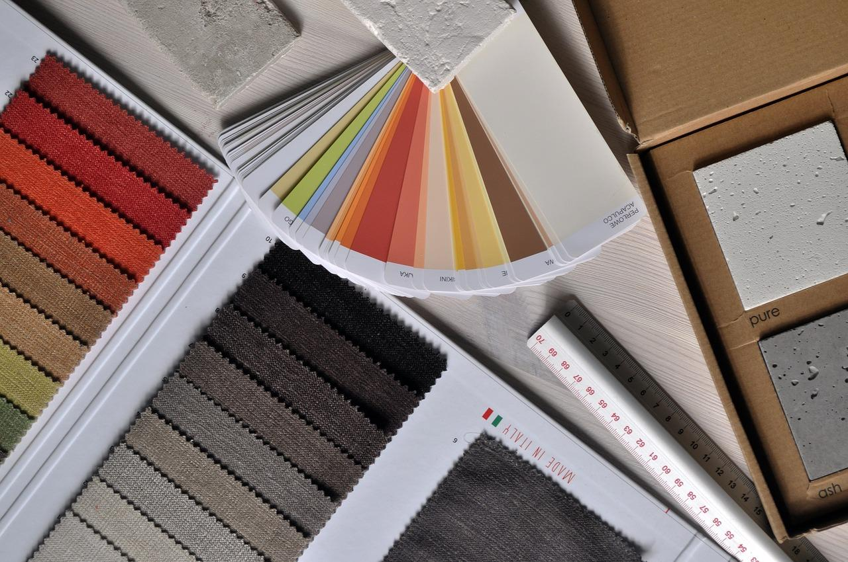

Fig. 4. Pixabay (n.d.), Material samples for testing

This will allow you to collate your selections and discuss the best possible solution. By carrying out the research, you will gain a vast knowledge of supplier-designer relationships which will underpin the foundation of your industry knowledge. Within the testing process you must show that there is a clear understanding of why you made the final selection of materials.

## Stage 6: Production of visuals and maquettes

At this stage, you should have settled on your preferred/best ideas, and now it’s time to create mock-ups of those designs. The production of visuals and maquettes allows the designer to test and demonstrate their ideas to a client. This stage of the design cycle will involve producing the design to scale either through the creation of Technical Drawings, or a 3D model created with design software (e.g. SketchUp, CAD etc). While there is still room for minor adjustments to your CAD design, the changes at this stage of the design process should be minimal. Using a visual display tool such as a sample board will also enhance the nature of the design proposal.

## Stage 7: Presentation of ideas

The objective of this step in the design process is to find out whether or not the design satisfies the client's requirements. The main aim of presenting your design(s) to a client or other relevant stakeholders is to obtain constructive feedback. With your conceptual ideas ready, it is time to meet the client and discuss the solution proposed.Your final design should be presented both verbally and visually with clarity, confidence and creativity. It is best practice to take your clients gently through the process and ensure that they understand your thinking behind each design decision at every stage.

Fig. 5. Unsplash (n.d.), Meeting with Client

Getting feedback on your work can be a challenging experience for any designer. It is, however, a vital step to help you refine your concept, deliver an exceptional design proposal that responds to your client’s wants and needs, while also offering the most appropriate design solutions. Since feedback can have a significant impact on the final design, try to seek out specific and meaningful comments from your client. This will help you identify areas for improvement. In some cases, the client may be too shy, or embarrassed to give their honest opinion, or they could use vague phrases to appear agreeable. This is where you may need to ask more specific questions about details within the design. Should your client not give you any actionable feedback, make sure you are certain that they are happy with the design proposal you have presented to them.

It is important to remember that no solution is perfect, and changes still may be required. This should not be taken as a personal attack, but should be considered part of the design process. It is also possible at this stage that your client may change their mind again so it is wise to have agreed on a number of revisions in advance. After that has been breached, then you can begin charging additional fees. It is usually standard practice that one or two revisions are offered within the initial agreed price, and any more thereafter are charged at a specific price.

## Stage 8: Response to feedback

It is important that you are prepared to offer the client an alternative proposal, should client feedback dictate this. The feedback you receive may require you to make modifications related to areas of improvement identified by the client. The adjustments may range from minor tweaks, to more extensive changes. Regardless of the scope, ensure you are clear on the exact details of the adjustments the client has requested. Through the ideas development (stage 3) you will have developed various options that will allow you the opportunity to refine the design where necessary.

## Stage 9: Production of final outcomes

Once adjustments have been made to your design, you will present it to your client again. You may do this many times but be prepared to present to the client over and over until they finally approve it. The production of final outcomes will consider the final design solutions with relevance to the client feedback. All work should be refined where necessary and final outcomes presented.



Fig. 6. Pexels (n.d.), The final sign-off by the client is a key step in the design process

It is good practice at this point to get your client to sign off the designs, by signing either the design package itself and/or an agreement that you will have drafted for them. The agreement must clearly state their acceptance and approval of the proposed designs. This way, you are protected from any future mishaps (such as your client changing their mind much later down the line). When your design gets the final evaluation and subsequent ‘green light’, it is ready for the distribution of your design plans to the relevant team members, for example, your project manager on the job, electricians, construction manager, etc. Ensure to export your design in the appropriate file format for your team to access and use accordingly.

## Stage 10: Evaluation

Through evaluation, you are offered the opportunity to reflect on what you have learned while working through the entire design cycle within a given project.This critical assessment allows you to identify strengths and areas for improvement, ensuring that future projects benefit from your insights and experiences.